#
# Work was made by SD#1253223
#

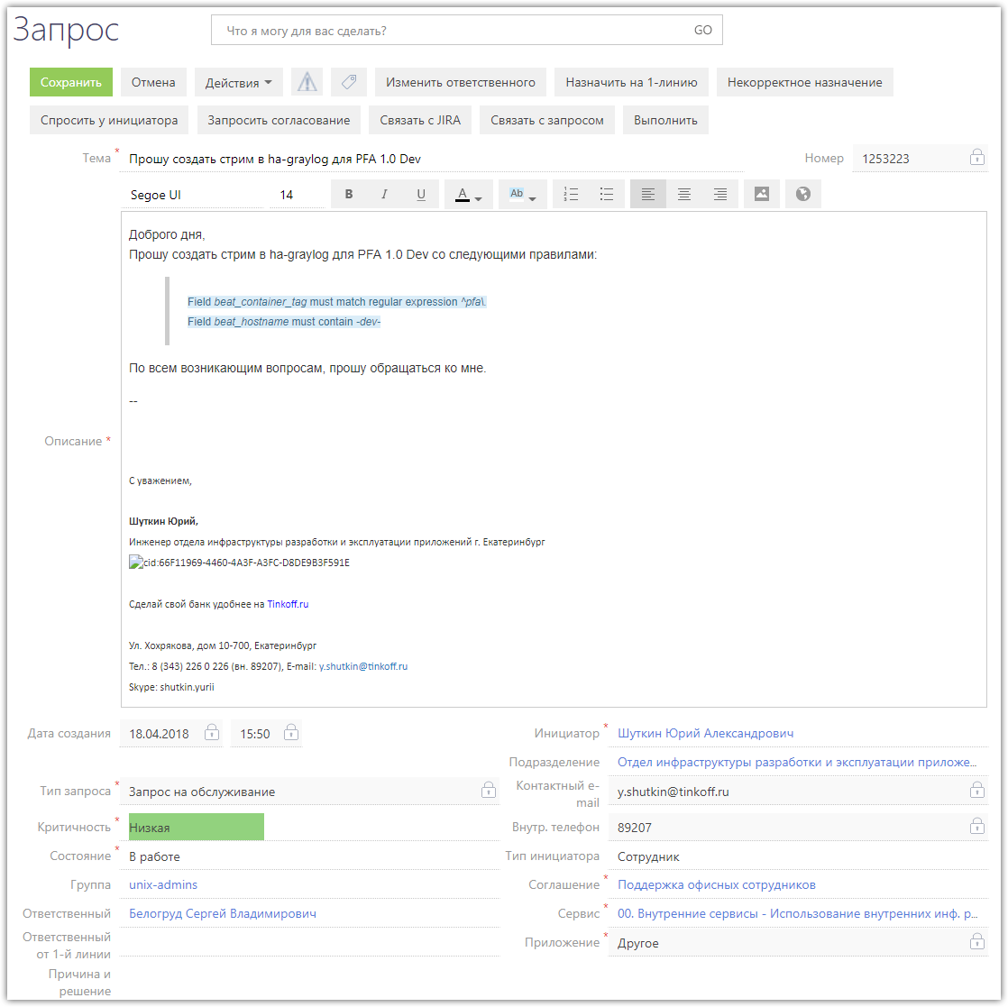
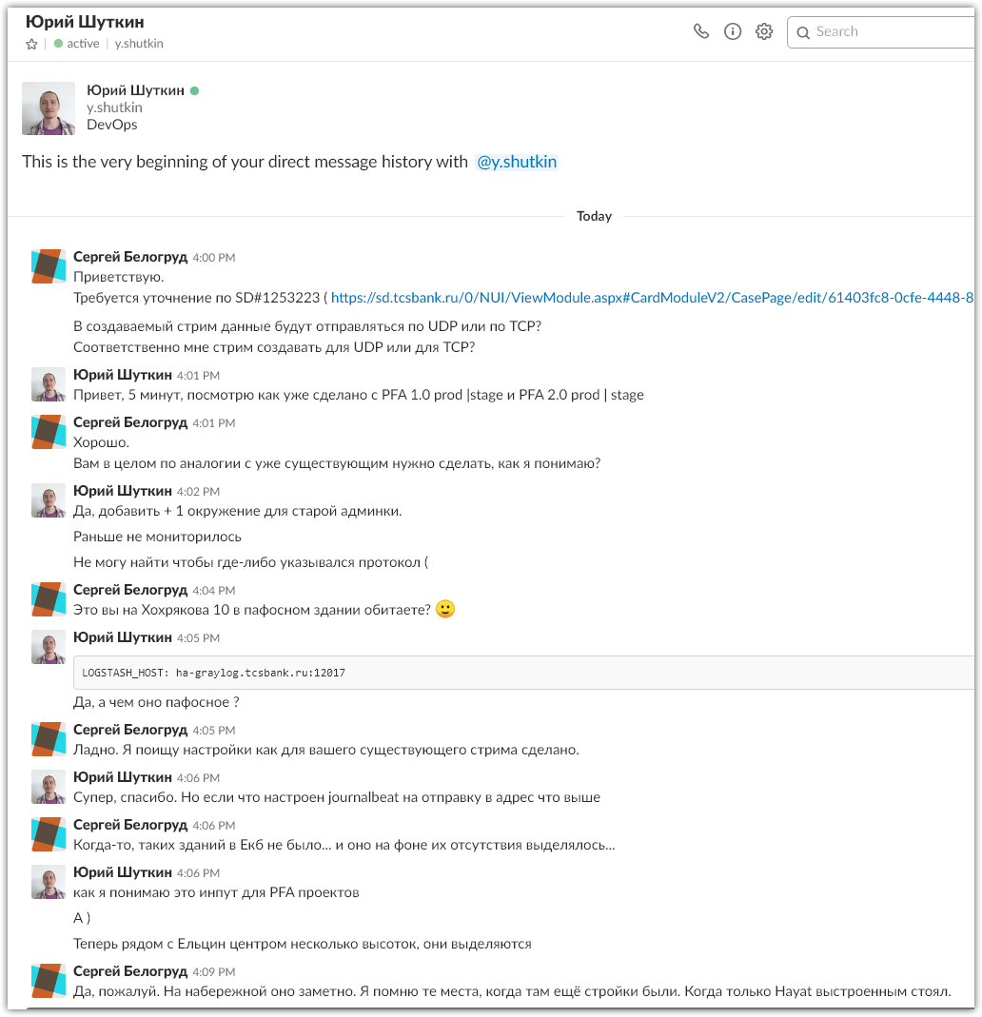
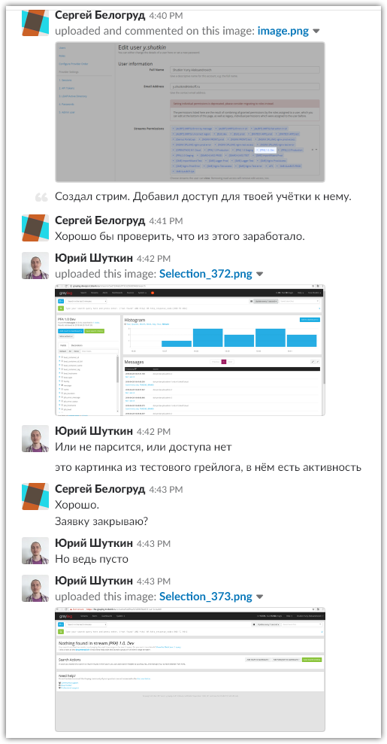
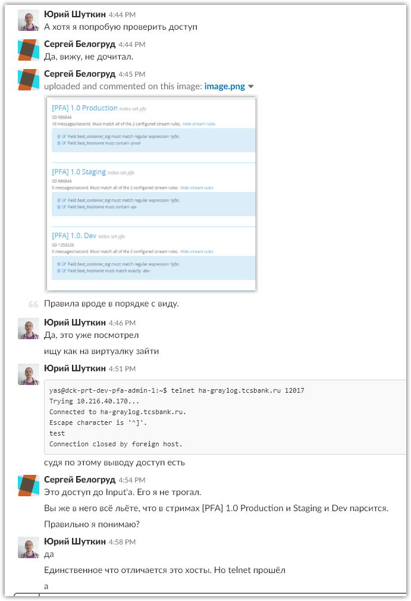
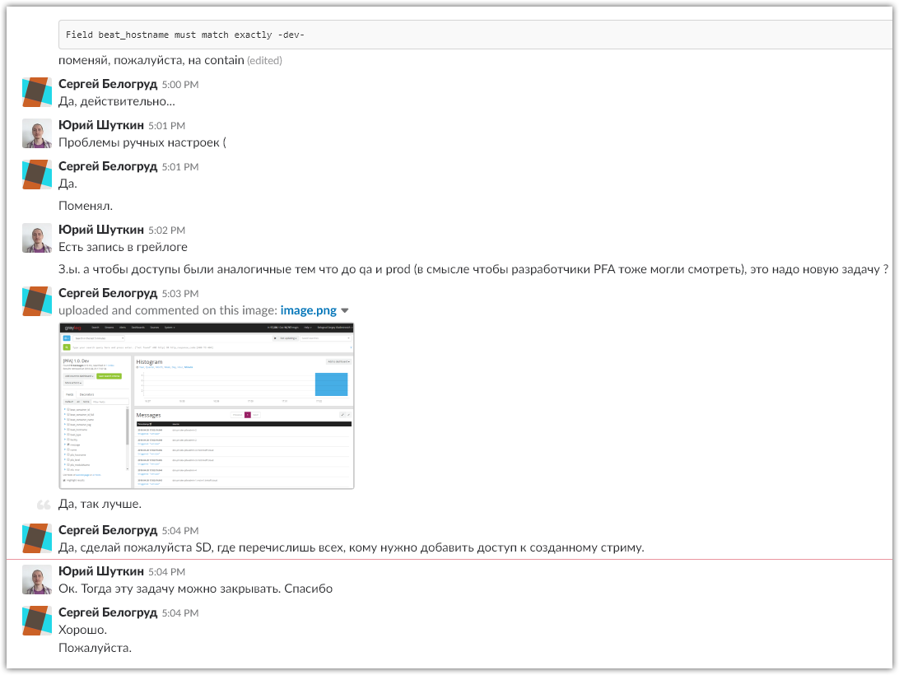

#
# I’ve found similar “PFA” streams.
#
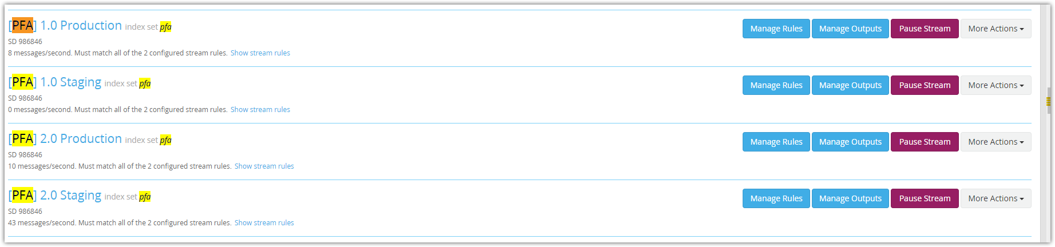
#
# For exists stream “[PFA] 1.0 Staging”, I’ve choosed “Clone…” option under drop list in button “More Actions”
# And here I’ve forgotten to fill in check-box “Remove matches from ….”. It’s need to be turned on, as it was made for other PFA streams.
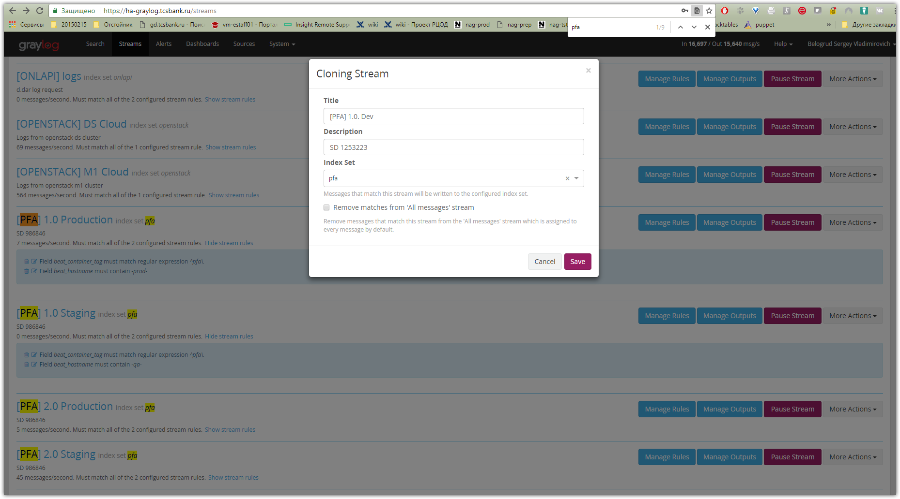

# Here is a duplicate of one of existed stream.
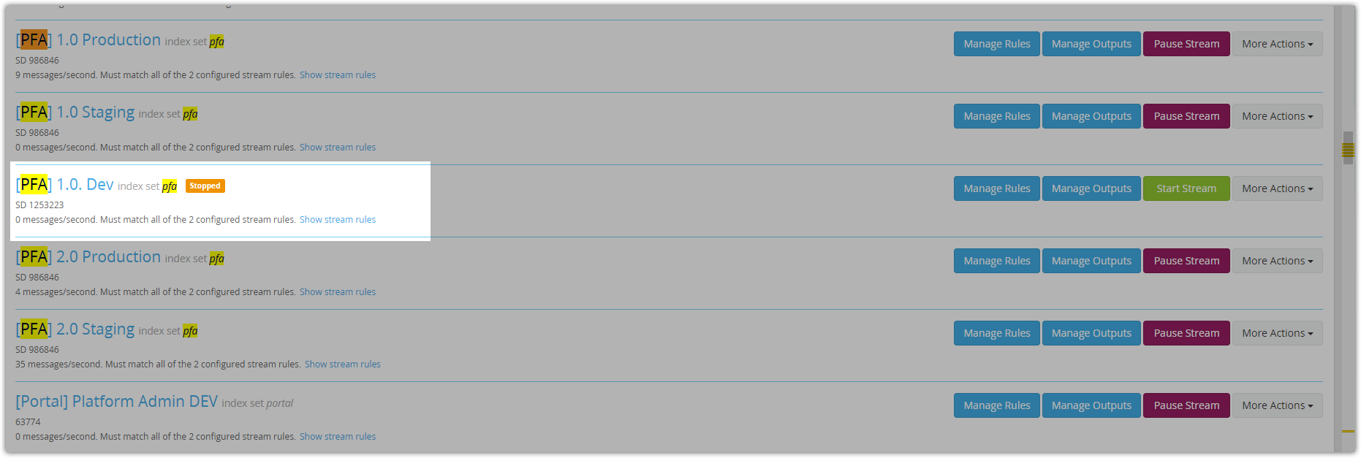

# As required in SD:
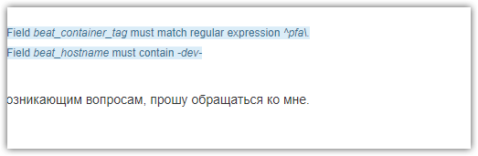
# I’ve created appropriate rule.
# Here I was made one mistake. I use “Type” : “match exactly” instead as it was made for other similar streams…
# It’s need to be used “contain”.
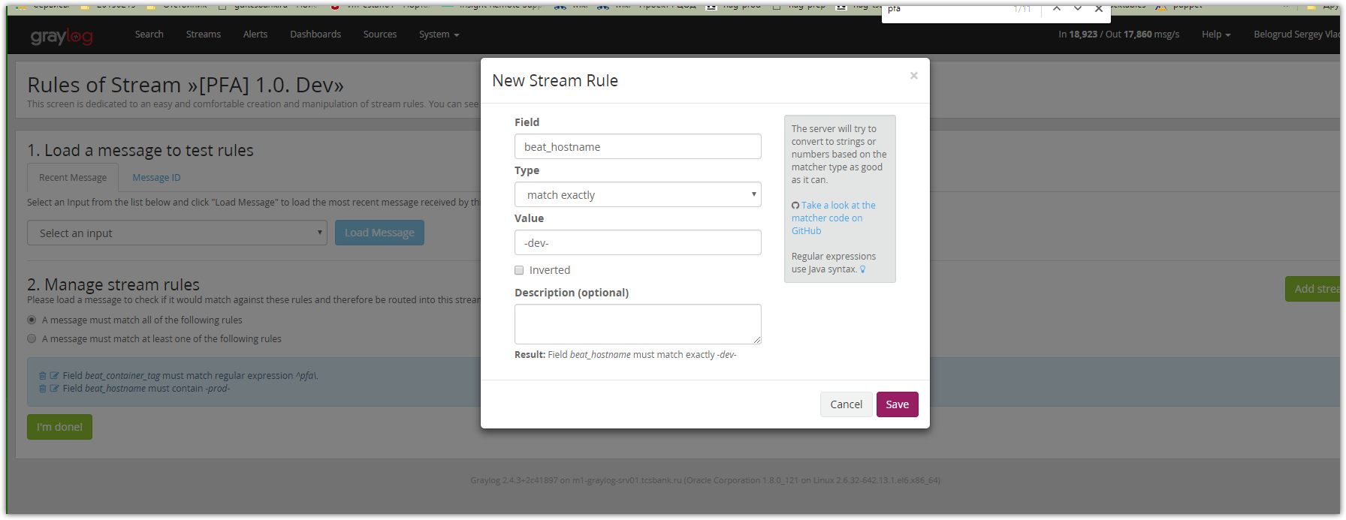

# Old rule, not needed already, I’ve removed. I’ve pressed on trash can sign.
# At this moment, here is what we have.
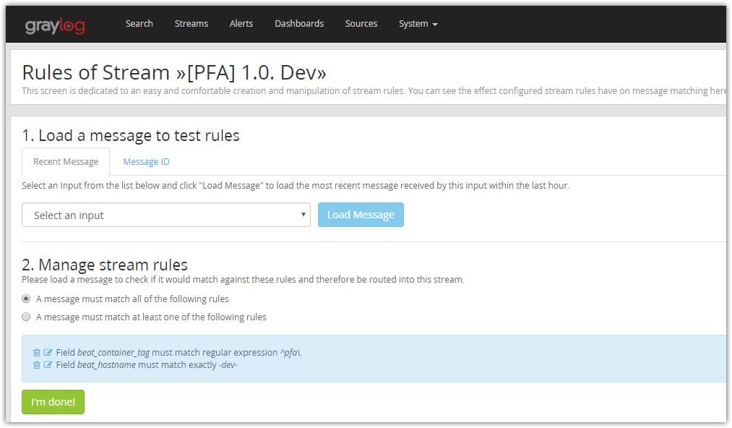

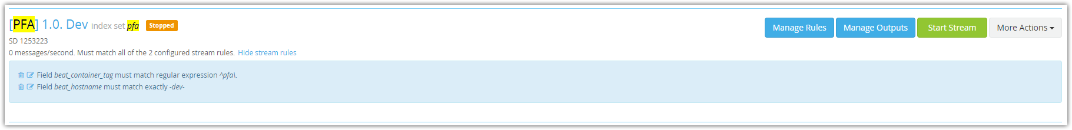

# I’ve pressed button “Start Stream”.
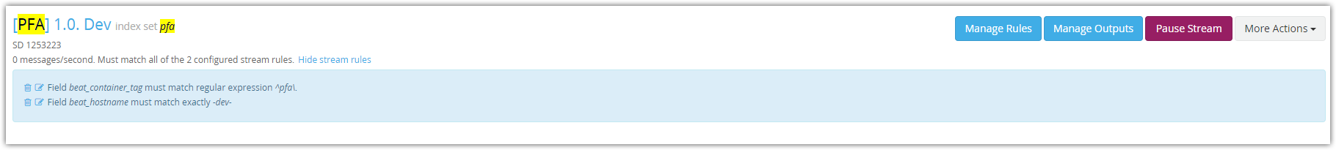

# I’ve granted access user to previously created stream.
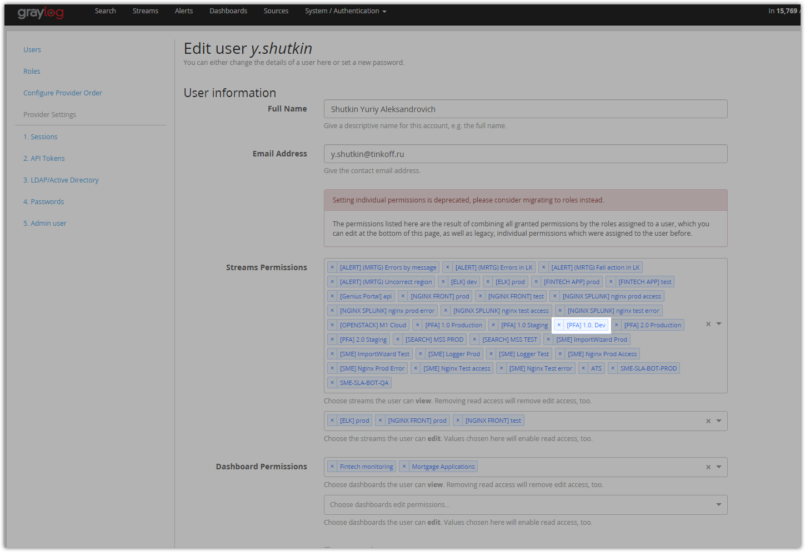

# I’ve open stream. But there is no new data in it...
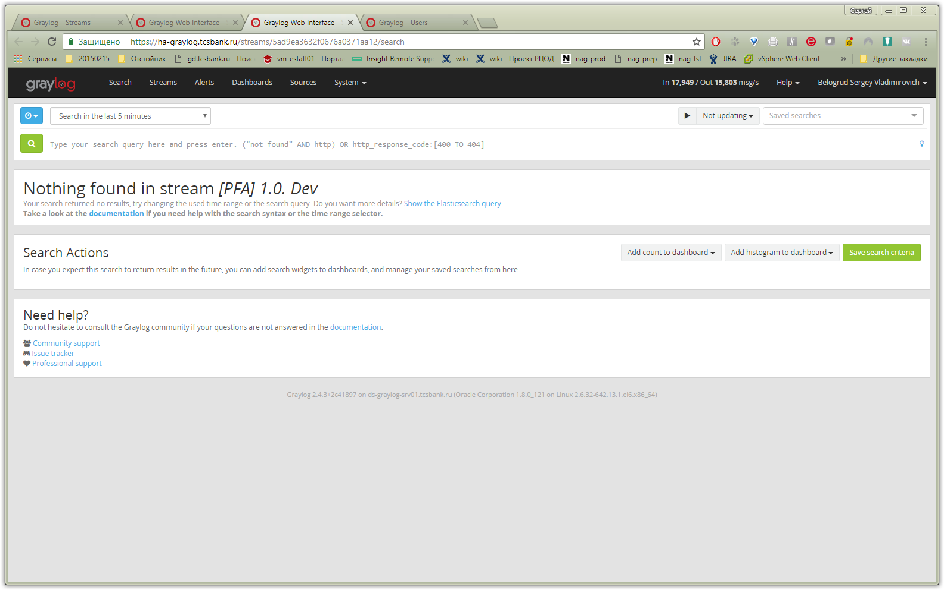

# Here I’ve corrected not turned on “Remove matches… “ option. It was not turned on by my mistake.
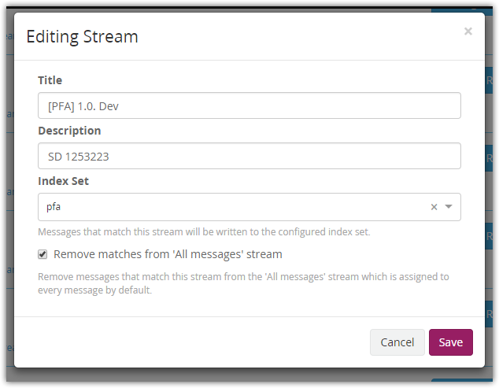

# Here I’ve changed “Type” field to “contain”.
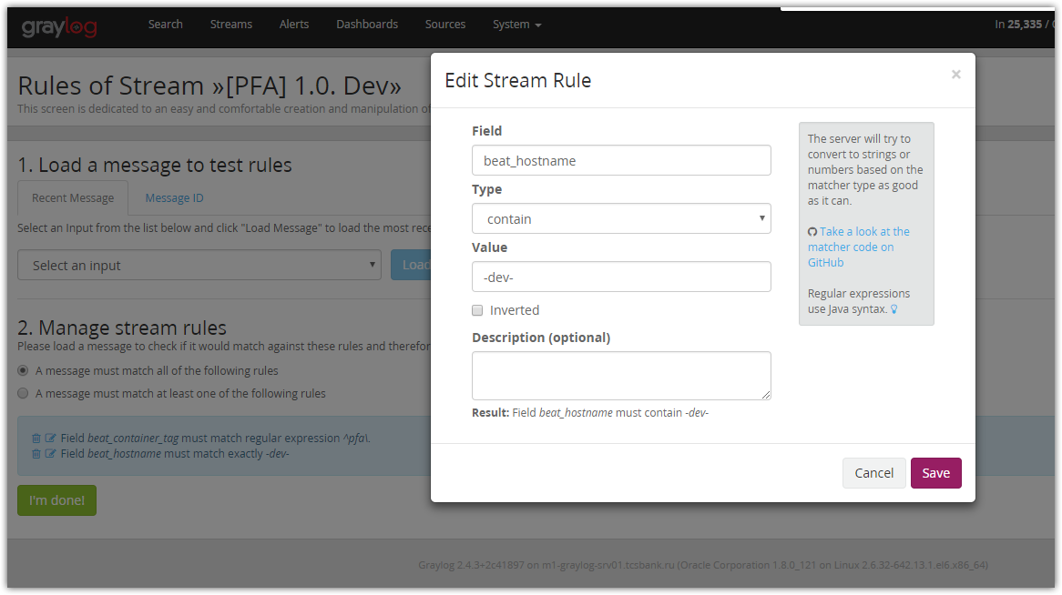
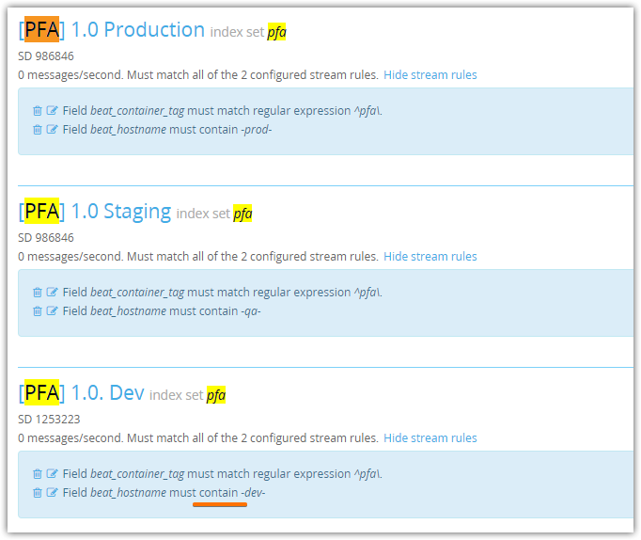

# After that correction were made, I’ve found the first messages, that was filteded by fresh created stream.
